Active Sonar System Design for Underwater Acoustic Sensing using Ultrasonic Piezoelectric Transducer

|  |
| --- |
| Saifur Rahman1 , Rahat Mahmood Khan2 , Navan Tanjeem Hossain2, Dr. Md. Ziaur Rahman Khan3  Research Assistant, School of Engineering and Computer Science, Independent University Bangladesh1  School of Engineering and Computer Science, Dept. of EEE, BRAC University, 66 Mohakhali, Dhaka–1212, Bangladesh2  Professor, Dept. of EEE, Bangladesh University of Engineering and Technology (BUET), Dhaka-1000, Bangladesh3  E-mail: saifur@iub.edu.bd, [rahat.mahmood.khan@g.bracu.ac.bd](mailto:rahat.mahmood.khan@g.bracu.ac.bd), [navan27@gmail.com](mailto:navan27@gmail.com), , [zrkhan@eee.buet.ac.bd](mailto:zrkhan@eee.buet.ac.bd) |

***Abstract* – These instructions give you basic guidelines forpreparing camera-ready papers for conference proceedings.**

***Keywords:  
Piezoelectric transducer excitation, sonar system, echo signal processing, underwater acoustics, underwater range calculation***

I. Introduction

Ultrasonic technology has been prevailing since decades **(tong, figueroa)**. The use of ultrasonic technology has multiple applications including ultrasonic distance measurement systems, SONAR (abbreviation) etc. The source of inspiration for the development of sonar technology has been derived from nature by imitating the navigation system of bats, dolphins and whales etc. **(Kaveh, Farhoudi)** using ultrasonic sound waves. This is known as echolocation as was first coined by Griffin **(Kaveh, Farhoudi - 18)**. Requirement of precision in distance measurement has been a crying need in numerous applications of science and technology. The need for precision in determining geometric distances led to the design and development of active ultrasonic transducers to utilize the properties of sound for such application **(Lee, Huang…)** like underwater perception, on air distance measurement etc.

The working mechanism of active ultrasonic transducers require continuous transducer excitation to transmit sound waves at ultrasonic ranges. In order to excite these transducers, the power supply has to be applied maintaining certain transducer specifications. The requirement of precise power at defined frequency is essential to avoid power loss and obtain optimum competences. The transmission of signals at resonant frequency depending on the characteristics of each transducer is thus necessary. The transducer parameters maintain versatility and every system is to be designed according to its own specifications. Therefore, commercial transducers need to have its own specified module to excite and receive the transmitted signals as echo. As mentioned by Wang & Tsai **(Wang, Tsai)**, transducers can be dynamically modelled using constitutive electrical and mechanical equations to study and analyse its responses. These equations could be employed to understand, characterize and simulate the behaviour of transducers for determining the requirements to design modules.

As transducers can be modelled using resistors and capacitors **(Lester W. Schmerr Jr. [Fundamentals of Ultrasonic Nondestructive Evaluation pp 1-13])**, the primary conditions for transducer excitation are power and frequency matching through RLC networks **(Yang, Wei, Zhang and Yao)**. Once, the power and frequency are matched according to the transducer impedance following the maximum power transfer theorem, the transducer will transmit bursts of ultrasonic waves with high efficiency. These waves will then generate reflected waves or echoes when they are obstructed. The echo will evidently have to be perceived so that the measurement of distance could be determined from the time of flight [TOF] **(Lee, Huang…)** and the speed of sound in the medium using speed-distance equations. However, the echo received are usually contaminated by noises from the environment. This signal requires refining through filters so that only the echo can be detected from the environment.

This paper proposes the transmitter and receiver module design for 200 kHz underwater ultrasonic transducers. The electro-acoustic equivalent model of the transducer is evaluated from the parametric calculation of selected commercial transducer’s manual. The transmitter module is designed to excite the transducer to generate acoustic wave capable of long-range underwater sensing. Commercial sonar module for low frequency transducer, e.g., 40 kHz transducer are widely available for interfacing with an Arduino. The Arduino compatible module, HC SR-04 [cite] and JSN SR04T [cite], are non-submergible to water and are also not capable for high resolution, long range acoustic sensing. The commercial long range sonar devices [cite] available for high resolution underwater applications are expensive and consumes large carrying space. This motivated our research to design a low cost, portable active sonar system for a higher frequency underwater transducer, capable of sensing long acoustic range and can also extract detailed information of underwater target object of interest.

As very limited number of resources is available for these types of transducers, the paper will bring a better impact through its proposed design. Among a few mentionable works in this field, **(Wang and Tsai)** developed transducer model using block diagram approach to develop dynamic model of thickness-mode piezoelectric transducer. They used their model to characterize the parameters for modelling and analyzing the behavior of piezoelectric transducers. On the context of methodological algorithm, **(Guarato, Laudan and Windmill)** worked on target localization using active sonar. In their system, they defined localized target by intersecting four ellipsoids between one transmitter and four receivers and calculated the time of flight. They focused on the localization principle and defined the system in a laboratory environment. Further, **(Luo, Han and Fan)** developed a review on tracking targets using ultrasonic acoustics. In their effort, they developed their literature on the basis of various algorithms that used tracking methods to trace targets. Additionally, **(Kuang, Jin, Cochran, Huang)** have developed a driving and measuring system to track the high-power transducer resonance and vibration velocity to stabilize the transducer for optimum capabilities. They made the system capable for monitoring the performance parameters of transducer in real time using their control algorithms and simulated the system in LabVIEW. This added to versatile use as the system could be implemented in a flexible manner on various modes of transducers. Furthermore, **(Yang, Wei, Zhang and Yao)** in their paper laboured on electrical impedance matching of piezoelectric ultrasonic transducer. They emphasized on 2 types of impedance matching network networks namely type I and II. These were series and parallel combinations of capacitance and inductance to model the electrical impedance matching network. They imitated the simulations on PSpice to analyse the time and frequency domain behaviours to characterize the response of the resonance and anti-resonance frequencies. We have used similar methodologies of impedance matching in this paper. In [cite], **(Josserand and Wolley)** designed a miniature high-resolution sonar imager using the frequency steered phased array technology. Their system devoid of high power, complex circuitry and processing units and consisted of large number of arrays to perceive the signals. Though the method presented a high-resolution image, the range covered by the system was shorter in comparison to the expectations of this paper. This paper identifies the existing research gap and proposes a low cost, simple modular active sonar system that would fill in the necessity of long-range underwater acoustic sensing for a frequency of 200 kHz piezoelectric underwater transducer.

**II. Transducer Selection**  
A typical commercial transducer specification is depicted in table 1. Based on the key parameters enlisted, Simulink model of active sonar system was designed. Long range sonar generally uses enclosed type transducer of which the outer peripheral is completely sealed. We choose piezoelectric crystal manufactured from PZT (Lead Zirconate Titanate) materials. There are several classes of PZT’s available **[8]**, each material having different physical characteristics and are subjected to different applications. We chose PZT-4, as it has high coupling factor and is also appropriate for high acoustic. Additionally, it is highly resistant to depolarization and the dielectric loss is minimum when driven by high power drive. Resonant frequency of the selected transducer is $200 kHz$ having a bandwidth $BW=8 kHz$.

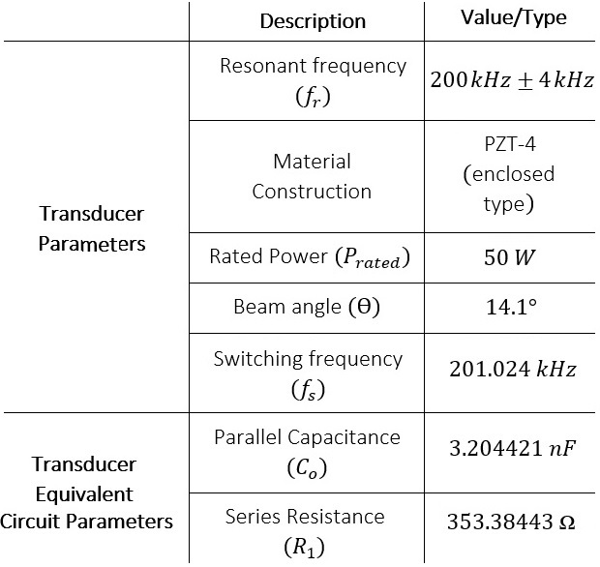

*Table.1**Selected Transducer Specifications*

Piezoelectric transducer commonly uses $40 kHz$, $200 kHz, 500 kHz$ frequency crystal. High frequency transducers are for ranging high resolution underwater information. Despite, high frequency transducer gives precise echo ranging data, it is a trade off with maximum distance coverage. Transmitted pulse for high frequency shorter pulse tends to attenuate at a greater rate than low frequency wider pulse. The selected BW=8 kHz is a narrow bandwidth which in contrast to wide bandwidth have less reverberations and shorter blanking distance. Beam angle of the selected transducer is 14.1°, which is considerably a narrow beam. Narrow beam acoustic signal provides greater directivity but has less angular coverage. Transducer having higher $P_{rated}$ has longer detection range and would eventually ensure stronger echo return. Rated power of the selected transducer is 50 W which is reasonable for several hundred metres range detection. An input power closer to the rated value is designed in the power drive stage in Sec. **III (b).**

**III. Transmitter Unit**

**III (a) Pulse Oscillator**

Pulse oscillator generates pulse wave at a frequency $f_{drive}$ which is equal to the resonance frequency $\left(f_{r}\right),$ to harvest optimum crystal vibration. Astable multivibrator using a

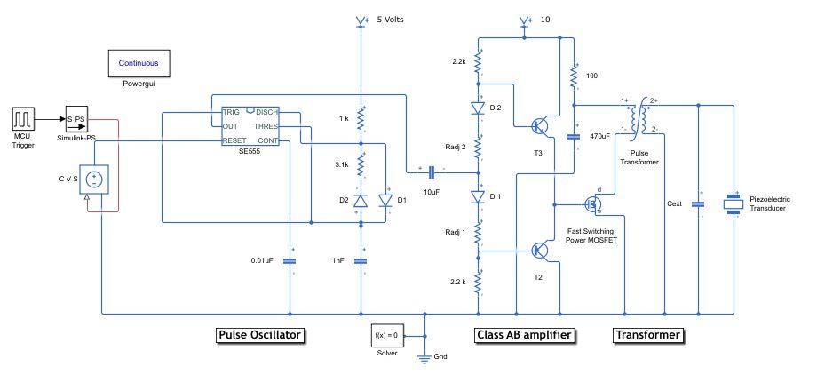 **Figure 1:** Transmitter Unit Schematics

class of 555 timer, SE555 IC was used to generate pulse excitation signal. This pulse excitation is controlled by the MCU (microcontroller unit) which switches the timer SE555 on or off to allow/hinder pulse excitation. Simulink design of this module is realized into two separate units as shown in **fig.1**.

First unit is the ‘MCU Trigger’, which controls number of cyclic pulses generated by timer in each burst. From the virtual oscilloscope output in **fig.2**, region A is the ON-period when MCU signals logic ‘1’. The width of this ON-period is directly proportional to the scope of information could be hold by return echo. During this period active bursts are generated continuously by the timer. Pulse width of this period can be adjusted to configure the number of cyclic pulses in each ON-period.   
Let, n be the number of cyclic pulses generated in each ON–period. Then the duration of each ON–period can be evaluated as follows:

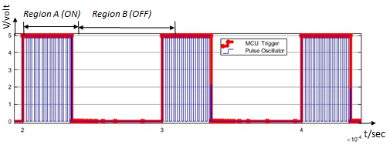 **Figure 2:** Pulse Oscillator output waveform

$T_{H}=n× \frac{1}{f_{r}}$**(1)**

where $T_{H}$ is the ON-period duration.

It’s better to fix ‘n’ and then calculate $T_{H}$. The standard value of $n$ are of order $8, 20, 40$ and so on.  
  
We chose $n=20$, then from Eq. 1 $T_{H}=100µsec$. This infers, to generate 20 cyclic pulses at each ON-period the MCU must hold the logic level ‘1’ for around $100µsec$.   
  
Second unit is the astable multivibrator SE555 timer, which continuously generates frequency at 200 kHz until $T_{H}$ goes down to logic 0. Transducer is in active transmission or non-listening mode (fig. region A), when $T_{H}$ is ‘high’. In practice, piezoelectric transducer has an unfavourable characteristic, known as ringing. This brings about the extension of transmission period more than $T_{H}$.   
  
This gives the total duration, $T_{total}= T_{H}+ T_{ringing}$, where $T_{ringing}$ is the excess time due to ringing. If this duration can be minimized the pulse excitation efficiency can be improved significantly.   
  
Region B is the listening (OFF- period), during this period transducer listens for echo and hence no transmission takes place. Transducer is completely isolated from the Tx unit, to prevent needless power loss and burst generation.   
  
From the second unit of pulse oscillator circuit following pre-design consideration is employed: $R_{B }> R_{A}$ 
  
, $C_{1 }=1nF$, ${ R}_{A}=1kΩ$, $C_{2 }=0.01µF$.  
  
The equations below were used to calculate values of $R_{B}$ and the duty cycle D, $T_{H}=(ln2) \left(R_{A}+ R_{B}\right)C_{1}$ 
  
 **(2) ${ T}_{L}=\left(ln2\right)R_{B}C_{1}$**  **(3)** where, $T_{H}$ corresponds to logic ‘1’ and $T_{L}$ corresponds to logic ‘0’, of cyclic pulse generated by the SE555 timer. To ensure the transducer operates at resonant frequency we set the driving frequency $f_{drive}=200 kHz$. Then, we calculated the value of $R_{B}=3.1kΩ$, after substituting the value of $R_{A}$ and $C_{1}$ in the $f_{drive}$ equation below $f_{drive}=\frac{1}{T}= \frac{1}{T_{H}+T_{L }}= \frac{1.44}{C_{1}(R_{A}+{2R}_{B})}$ 
 . **(4)**   
 The duty cycle *D* gives the percentage of the total duration $T_{H}$ is high, i.e., $D= \frac{T_{H}}{T_{H} + T_{L}}×100$, which can also be evaluated as $D= \frac{R_{A}+ R_{B}}{R_{A}+ {2R}_{B}}$ $=$ $56.9\% .$**(5)**  
  
 **III (b) Power Drive**

High voltage signal excitation is required to drive the transducer to maximize the mechanical vibration of the piezoelectric crystal which produces acoustic sound wave. Driven power must be close to the rated power of the transducer ($P_{rated}$ = 50W). In this stage our focus is to design a circuit module which is capable to excite transducer to yield maximum acoustic range and ensure significant echo return. Generally, two ways of excitation are available **[9]:**   
a) Transformer Drive (for enclosed type transducer),  
b) Power MOSFET Drive (for open type transducer).  
  
High rated, enclosed type transducer requires use of transformer for excitation. Even though, $P_{rated}=50W$ might not appear to be large excitation power, the purpose behind the use of transformer is, it places itself as the best candidate to act both as power drive and impedance matching circuit. In sonar system design, transformer is widely used to step up voltage and its turns ratio is adjusted to match the impedance of the transducer. This ensures maximum power at the load, in this case which is the transducer. In practical application, which involves sensing long acoustic range e.g., in ocean ranging, ultrasonic transducer might need to be excited at $P_{rated}$ in several ‘kW’. Alternate other than transformer excitation is roughly not there.   
Pulse oscillator output voltage of ‘5V’ and low output current, is incapable of exciting primary side of the transformer. Therefore, a linear power amplifier (LPA) was used to trigger voltage and control $I_{p}$ (primary winding current) of the transformer. Class AB an LPA type amplifier was chosen for our circuit design. Compared to other LPA’s it has low cross-over distortion and is more efficient in terms of power amplification. In **fig.1**,class AB unit, diodes D1 & D2 and transistors T1 & T2 are matching pairs. If these components are non-identical cross-over distortion could be reflected at the output of Class AB amplifier (input to primary winding of the transformer). Power drive stage is segmented into two distinctive parts, Class AB amplifier unit and transformer unit. A fast-switching power Mosfet **(model:)** as shown in **fig.1** was used to withstand large current at primary winding of the transformer.  
   
Transducer needs to be excited at 50W and 200 kHz frequency to maximize the electro-acoustic conversion. To achieve this, we need to consider both the rated power and frequency of the transducer, at transmitter unit. Signal output from pulse oscillator is in pulse waveform at frequency 200 kHz and $56.9\%$ duty cycle, when transducer is in transmission mode. Based on the output generated by pulse oscillator, we chose Pulse transformer at the transformer unit. The specification of the selected transformer is depicted in Table 2.

Pulse transformers are generally used in application when the operating frequency is of high order. High frequency transformers have few advantages in material construction **[10]**:  
  
 a) as the frequency increases the transformer shrinks in size  
 b) less Cu wire required which reduces Cu loss  
 c) different geometric construction available **[11]**.  
  
Despite having upper hands over low frequency transformer in some respect, HF transformer brings about few drawbacks. The skin effect and proximity effect are the major challenges which need additional consideration in practical design of pulse transformer. Skin effect results due to high frequency current streaming around the conductor.Litz wire are the common wire strands used to minimize this effect and reduce high frequency Cu loss as much as possible. This typical wire is twisted enabling current to distribute evenly, which is how skin effect can be reduced. Proximity effect are eddy current losses, which are mainly due to magnetic fields induced by nearby conductors. Several practical design techniques described in **[10]**, can be followed to implement efficient HF pulse transformer.   
  
  
 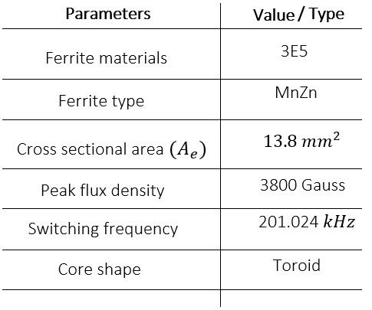

Table.2  
 *Model Parameters of Pulse Transformer*

From Table 2, ferrite types and materials are application specific, mostly selected based on high permeability ($µ_{I=}10000$), minimum loss factor and large $B_{m}$ value. Array of ferrite material grade and their specifications are listed in the component note **[12].**   
  
Transformer parameters used in our simulation model are evaluated from the equations below:

$L_{s}= \frac{1}{C_{o}×{(2πf_{s})}^{2}}$**(6) $P_{rated}= \frac{{E_{s}}^{2}}{R_{1}}$**   
   
 **(7) $P_{rated}= E_{s}× I_{s},$**   
  
  **(8)**

where, $L_{s}$ is the inductance value of the secondary winding and $E_{s}$ and $I_{s}$ are the required voltage and current of the secondary winding, respectively.

Using the values of $C_{o}$& $R_{1}$ from Table.1, we obtain $L_{s}$ = 0.196mH. From Eq.7 and Eq.8, we obtain ${ E}_{s}=132.93V$ and $I_{s}=0.376A.$ Next we evaluate the turns ratio and primary winding parameters, $N_{p}= \frac{E_{p}× {10}^{8}}{kA_{e}B_{m}f_{s}}$ 
  
  
 **[Toroid Parameter Calc]** **(9) $N_{s}=n× N_{p}$**   
  
 **(10) $n=\frac{E_{s}}{E_{p}}$**  **(11) $\frac{L_{S}}{L_{P}}= {\left(\frac{N_{S}}{N_{P}}\right)}^{2}$**    
 **(12) $\frac{I_{S}}{I_{P}}= \frac{1}{n}$**  **(13)** In **eq.** 9, $N_{p}$ is the number of turns of the primary winding, $E_{p}$ is the voltage at the primary side and $k$ is a constant. The value of $k$ depends on the wave shape generated by the transformer [**Toroid_Parameter_Calculation**]. For a symmetric pulse, the value of $k$ is considered as 4, which is the required value in our case. The notations $A_{e}{, B}_{m}$ and $f_{s}$ are defined in **Table** 2. In **eq.** (10-13), $N_{s}$ is the number of turns of the secondary winding and $n$ is the turns ratio of the transformer, $L_{p}$ is the inductance of the primary winding, and $I_{P}$ is the current at the primary winding.  
  
From Eq.(9-13), the required value for our simulations are $N_{p}$ = 5 turns, $N_{s}=135 turns, n=27$ and $I_{p}=10.152A$.   
  
The design parameters of Class AB amplifier can be readjusted to control the current $I_{p}$. But the drive current might exceed the current values of primary and secondary windings, due to unwanted transducer feature, such as ringing. To avoid this, external capacitor $C_{ext}$ was connected to absorb excess charge. It is however better to remain at slight capacitive region (phase angle shy of 0°) of impedance response as shown in **fig.4**.  
  
  
 **III (c) Impedance Matching**  
Driving voltage $V_{drive}$ delivered by the power drive circuit to the piezoelectric transducer results in electro-acoustic conversion from electrical energy to acoustic energy. The mechanical vibration of the piezoelectric crystal is in correspondence to the applied $f_{drive}$. Mechanical response reaches optimum level when the natural frequency of the piezoelectric material matches with the driving frequency ${ f}_{drive}$. The frequency of the piezoelectric crystal at which the response occurs is termed as the resonance frequency ${ f}_{r}$. Transducer has specific resonant frequency which is a function of the material composition and mechanical dimension. The objective of impedance matching unit is to drive the transducer to work at ${ f}_{r}$, to extract maximum mechanical vibration of the piezoelectric crystal, hence maximum efficiency in electro-acoustic conversion. Naturally, transducers are capacitive and have high input impedance compared to the output impedance of the power drive circuit i.e., $Z_{out}\left(Power drive \right){ Z}_{in }(Piezoelectric crystal)$. Due to the impedance mismatch, huge energy is wasted if excited in such condition and in turn the resultant transmission efficiency is low. To attain efficient transmission the capacitive effect of the transducer must be resonated out. This is achieved by exciting transducer to vibrate at ${ f}_{r}$.   
   
Several impedance matching techniques are available, of which two common ways are explained below:  
  
a) The simplest of method is to add external inductor by trial-and-error methods **[13]** until the overall impedance of the transducer is purely resistive. It might facilitate simplicity but requires several iterations which is unfeasible in practical case. Moreover, for high powered transducer e.g., Piezoelectric Tonpilz this technique is inconvenient.   
  
b) More rational and systemized approach is to use transformer for both power drive and impedance matching units. In our case, we used this technique to create simulation of power drive as well as to impedance match transducer. Turns ratio of the secondary coil of the transformer was adjusted to make the transducer purely resistive. This process resonates out the capacitance of the transducer and compensates for imaginary component of the impedance, not the real part. A proposed methodology has been analysed in this paper **[14],** where both the imaginary and real part was matched. We restrict out paper to resonate imaginary component and use approximation method by adjusting ${ N}_{s }$ (secondary turn ratio) until maximum power could be obtained.   
  
Piezoelectric transducer can be modeled as mechanical portion and electrical portion. Both the individual portions can be compounded into BVD (Butterworth-Van-Dyke model). This model was used to formulate the expression for input impedance of the transducer as seen by the transformer.  
BVD model parameters have been inserted in **Fig. 3**, for selected transducer. The branch parameters R1, L1 and C1 depicts mechanical portion and Co the electrical portion, following the BVD model. The overall impedance *Z(s)* of this model is capacitive for the parameters as shown in Fig.3. Simplified general equation of input impedance *Z(s)* is given by Eq. 14.  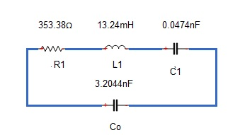 **Fig.3:** BVD model of Piezoelectric   
 Transducer $Z\left(s\right)=\frac{s^{2}L_{1}C_{1}+ sR_{1}C_{1}+1}{s^{3}L_{1}C_{1}C_{o}+{ s}^{2}R_{1}C_{1}C_{o}+sC_{o}+ sC_{1}}$  
 **(14)**

After plugging the value of the parameters in Eq. (14), Z(s) can be further simplified to Eq. (15). $Z\left(s\right)=\frac{{(6.27×{10}^{-13})s}^{2}+ (1.67×{10}^{-8})s+1}{{(2.01×{10}^{-21})s}^{3}+{ (5.36×{10}^{-17})s}^{2}+(3.25×{10}^{-9})s}$ 
  
 **(15)**

Next, we evaluate the resonant frequency $(fr)$ and anti-resonant frequency $(fa)$, using the equations below: $fr$ = $\frac{1}{2π√L_{1}C_{1}}= 201.02 kHz$**(16)**

$fa$ = $\frac{1}{2π√\frac{{ L}_{1}CoC_{1}}{C_{1}+C_{o}}}= 202.50 kHz.$**(17)**   
  
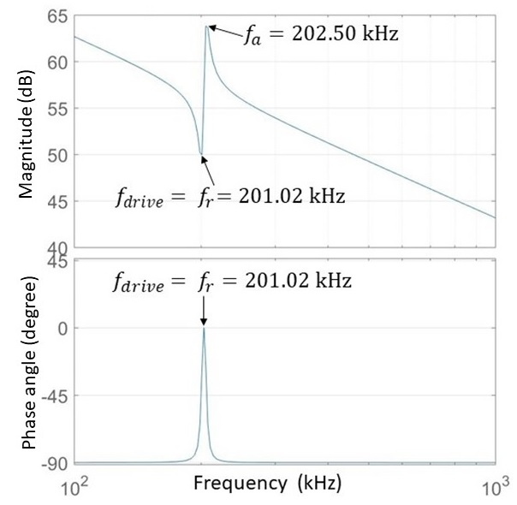

**Fig.4:** Impedance matching response   
 (after matching)

From the impedance magnitude response graph **fig.4**, the frequency at the trough is the resonant frequency ${ 'f}_{r}'$, and the frequency at the peak is the anti-resonant frequency ${ 'f}_{a}'$. The electro-acoustic gain ratio is maximum near ${ f}_{r}$ and the electro-acoustic power is maximum near ${ 'f}_{a}'$ [\cite Sensors17]. Phase plot of impedance response depicts characteristic nature of a piezoelectric transducer. Piezoelectric transducer acts like a capacitor without any external load. Therefore, before $f_{drive}$ is applied, the current **I** leads the voltage **V,** and the phase angle resides in the capacitive region. After $f_{drive}$ is applied and $f_{drive}$ approaches $fr$, the phase angle reaches ‘0’ degree, i.e., when **I** is in phase with **V**. The phase angle ‘0’ degree, confirms the excess capacitive effect of the transducer has been nullified with the addition of inductive effect at ${ f}_{r}$.

**IV. Receiver Unit**   
   
Transmitted signals are reflected if there lies an impedance mismatch between acoustic boundaries. The strength of the reflected signal is directly proportional to the difference of the impedance between acoustic mediums. At the acoustic boundary fraction of signal is transmitted and a fraction is reflected. An echo signal is the reflected wave by the acoustic boundary. It contains trait of the acoustic boundary; its structural and physical properties are embedded in it. The signal energy flow at the acoustic boundary can be modelled by the active sonar equation as given in Eq.18. It aggregates the general principle of underwater medium, additive noise, reflected object trait and other underlying sonar characteristics. Reverse electro-acoustic conversion takes place at the receiving phase when the acoustic signal is converted back to electric signal by the transducer. Efficiency of this conversion is dependent on the receive sensitivity of the transducer in our case which is -190dB. $SL-2TL+TS+GS+GT-NL=DT$  
  
 **[1]** **(18)   
Active Sonar Equation.**An arbitrary echo signal is formed by amplitude modulation of a 200 kHz carrier wave and adding AWGN noise, $N∼(0,σ^{2})$ to the modulated signal. This waveform as shown in **fig: 6** is fed into the input of the receiver unit. From the receiver schematics in **fig: 5**, preamplifier, echo detector, TVG (time varied gain) and comparator circuit design parameter depends on the amplitude of the arbitrary echo signal. The design parameters of the bandpass filter (BP) depend on the transducer center frequency $f_{c}$ = 200 kHz (from Table 1).

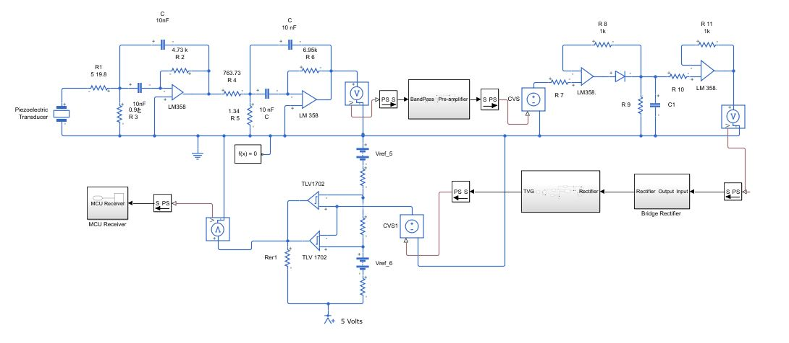

**Fig.5: Receiver unit schematics**

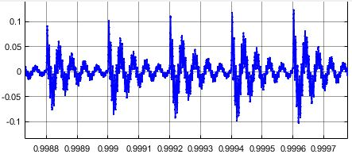  
   
 **Figure.6: Echo +AWGN**

**IV. a BandPass Filter**

The bandpass filter is the initial stage of receiving unit. It matches filter response with the center frequency $f_{c}$ of the transducer. Strongest signal lies around the bandwidth of $f_{c}$, band pass filter filters the received echo signal within the bandwidth range of $f_{c}$. This improves the SNR (signal-to-noise ratio), by blocking the uninformative echo which is out of the range of BW of $f_{c}$. Output of BP filter leaves informative echo signal to be amplified by the Preamplifier, the fixed gain amplifier stage **[15]**. In addition to intensifying the useful informative signal, reverberation due to environment noise are also filtered out. High SNR and precise ranging information can be obtained in the process.

Selection of type of band pass filter is important. To obtain flat passband and steep stopband of filter, 4th order was chosen for optimum filter response. Butterworth active band pass filter using MFG topology was used for our filter design. This typical filter was chosen as it provides better pulse response and hinders signal attenuation more efficiently than the other existing types. The circuitry parameters of resistors {$R_{1}, R_{2},…, R_{6}$} and the value of the capacitor, $C$ was determined from $f_{c}$ and $BW=8 kHz$. Bandwidth of filter must nearly match that of the transducer. If we chose design parameters which yields too small ‘BW’, than original information might be lost. On the other hand, larger ‘BW’ would open the doorway to ambient noise from under water to coalesce with the echo signal. The design parameters have been evaluated and derived from the following equations **[16] :**

${ α}^{2}+{\left[\frac{α.ω.a_{1}}{b_{1}\left(1+α^{2}\right)}\right]}^{2}+\frac{1}{α^{2}}-\left[\frac{ω^{2}}{b_{1}}\right]=$ 0 (**19**)

Where, $ω=\frac{BW}{fc}$ = 0.04 and the constant terms $a_{1}$ and $b_{1}$ are $\sqrt{2}$ and 1, respectively. Substituting the values in Eq. (19) and simplifying, characteristic polynomial equation obtained is shown below: $$α^{8}+4α^{7}+5.99α^{6}+3.99α^{5}-7.6α^{4}+3.99α^{3}+5.99α^{2}$$ $+ 4α+1=0$
  
 (**20**)   
  
Solving Eq.(20) the real root of $α$ is +0.825. The mid frequencies of the partial filter f $m_{1}=fc/α$ and f $m_{2}=αfc$ are calculated to be 242.4kHz and 165khz, respectively. These frequencies are necessary to evaluate the values of the passive components of the circuit. The evaluated values of the resistors and capacitors are shown in the received circuit schematics. The other parameters of filter evaluated are:

pole quality of partial filter $Q_{i}$ = 36.01;  
individual gain of partial filter $Am_{i}$ = 4.55V/V;

Overall transfer function of the 4th order Butterworth band pass filter can be given by Eq. (21).

$A\left(s\right)=\frac{\left(\frac{A_{m}ω^{2}}{b_{1}}\right)s^{2}}{1+\left(\left(\frac{a_{1}}{b_{1}}\right)ω\right)s+\left(2+\left(\frac{ω^{2}}{b_{1}}\right)\right)s^{2}+ \left(\left(\frac{a_{1}}{b_{1}}\right)ω\right)s^{3}+s^{4}}$**(21)** Echo signal is amplified after the BP stage to avoid the additive noise to amplify conjointly. Hence, mid frequency gain $A_{m}$ was considered to be unity. Plugging all the obtained constant terms in Eq. (21), the required transfer function for our circuit can be given by Eq. (22).

$A\left(s\right)$*= $\frac{0.0016s^{2}}{s^{4}+0.0566s^{3}+2.002s^{2}+0.0566s+1}$* (**22**)   
  
First stage of amplification is done immediately after the BP filter. The signal strength of echo highly depends on application range and type of transducer used in active sonar system. The range of echo signal lies in mV voltage level, for our customized echo signal. In practice, the range can be in lower order due to reverberation (dominant source of noise) or other sources of attenuation. We can set a fixed value of gain at the Preamplifier if the attenuation factors associated with the acoustic medium and the transducer sensitivities are known.

Another important parameter we need to account for in setting the value of Preamplifier is the SPL (sound pressure level).

Transmitted acoustic wave exerts force on the particles of the material medium, the magnitude of this force is measured by the SPL It determines transducer sensitivity, which is also inclined to the quality of electro-acoustic conversion. Manufacturer of transducer usually provides with the launch and receive sensitivity based on the construction of piezo-electric material. SPL can be defined as given in Eq. (23), $SPL={\frac{P_{s}}{P_{ref} }}$ 
(**23**) where $P_{s}$ is the source pressure and $P_{ref}$ is the reference pressure, oftentimes taken as 1µPa, 1µbar and 0.0002µbar **[17]**.   
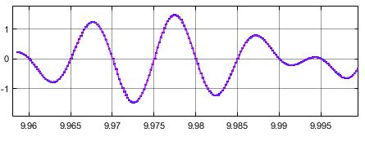**Figure.7: Echo after fixed gain amplifier** **IV. b Echo detector**

The band passed echo is then filtered by a full wave bridge rectifier. Rectified signal is then processed to detect the maximum amplitude value at the peak detector circuit. Since positive echoes are ensured by the rectifier, positive peak detector with only a forward bias diode will serve our purpose. Echoes are generally of weaker strength and fall in ‘mV’ voltage level range. This magnitude reduces as the acoustic range under test increases and received echo is highly attenuated. Before proceeding into echo detector circuit design, these factors need to be considered. Components of this module need to be adjusted according to received signal amplitude. At the first stage, during positive half cycle diode **‘D’** is forward biased which charges Capacitor **‘C’** to its peak value. During negative half cycle output of capacitor Vc > Vout, which makes diode **D** reverse biased. The output terminal is isolated from the input, which brings about capacitor role to discharge through resistor **‘R3’**. The rate of which is determined by the discharge time constant. Duration of it is solely determined by the value of **‘C’** and ‘**R3**’. Next stage of the circuit, a voltage follower has been used; it hinders any undesirable discharge of capacitor due to loading effect. A feedback resistor of ‘1KΩ’ was required to reduce offset input leakage current. Selection of op amp needs to be precise as maximum voltage level we are dealing with is very low in magnitude. Characteristic op amp having high slew rate needs to be chosen to avoid limiting detector to reach its peak value. Decoding range information will be tougher if the maximum voltage level is clipped off. Post-amplification was done after echo detector stage. A basic non-inverting amplifier can be used to amplify peak detected echo to the desired voltage level. However, this technique is more unpractical as it requires several iterations and adjustment needs to be done for each stage of range calculation. Time varied gain (TVG) can be employed for a specific application which increases dB level with time. TVG makes separate targets of identical size to be appearing as it is, even though they are isolated by large distance. In circuitry, according to the inverse square law of spherical divergence, it varies with time to make up for the proportional decrease in receive signal magnitude. Acoustic beam intensity drops by around 6dB for every distance doubled **[18].** Inaddition to distance covered echo signal is attenuated due to several loss factors as can be explained by ‘Sonar equation’ **.**TVG must compensate for this drop by detecting and elevating voltage level in multiple steps.   
  
 **IV. c**  **Comparator**

Echo threshold comparator calibrates acoustic range extending from near-field region to maximum far-field region of targets. Bursts are transmitted and received within this scope only. It prevents power drive to transmit high power burst needlessly out of calibration range and wait for receiving echo which are out of interest. The major purpose of ADC calibration is it saves power as well as improves data rate at which signal could be processed and analyzed by MCU. Initially, the range was estimated from echo detector output, and both the minimum and maximum amplitude values were noted. These extreme values would let us set the lower and upper threshold for the comparator circuit. It can be tuned by adjusting dc reference voltage and variable resistor ‘**R2’. C**omparator circuit was used to set lower threshold (**VTHL**) and the upper threshold (**VTHH**) voltages **(fig.8)**. The output voltage is high when **VTHH <Vcomp<VTHL** and low out of this limit. Lower DC reference voltage was set to signal out portion of echo signals which have amplitude below **VTHL,** signal probable from the weak object. Higher DC reference voltage was set to filter out echo signals which are above **VTHH,** signal resulting from additive noise. The pulse width of the comparator is proportional to ranging distance. Acoustic information is encoded in the duty cycle of the comparator pulse. Near objects will return stronger echo and intensify larger pulse width. On the contrary, distant objects respond slowly and have shorter pulse width. Analog comparator of this kind works as a 1-bit ADC system, which checks for only two voltage levels VTHH & VTHL. The output of which is in TTL level digital signal that can be easily fed into high-end MCU. Further, based on programmed algorithm, echo signal can be decoded to unfold ranging information about the target. High-resolution sampling could be achieved using multi-bit analysis. Smaller targets can be detected and resolved by increasing ‘n’ number of bits and the speed of sampling. MCU can be programmed to compare signal strength against sample threshold. Problem with this approach is it gets far more complicated with the increase in ‘n’ and sampling speed **[20]**.   
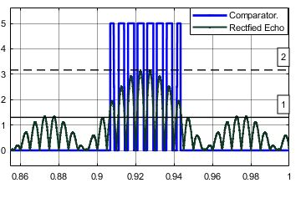   
 **Figure.8: Comparator and rectified Echo**   
   
 **V. Range Calculation**

Range from is calculated using TOF method, delays due to circuitry components were not taken into consideration. The difference between negative as positive edges as shown in **fig.9** is our desired TOF. Range is calculated using Eq.(24)  
  
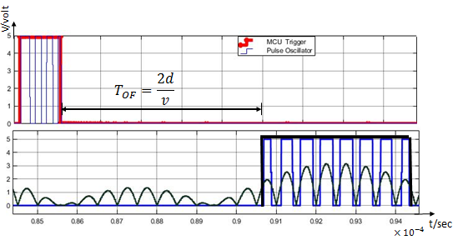 **Figure.9: TOF measurement $R=\frac{cT_{OF}}{2}$**    
  
  
 (**24**)   
  
where, c is the acoustic speed of the medium. At an instant when multiple echoes are received by the transducer, signal having greatest strength are taken into consideration to calculate R. The other parameter which is of interest is range resolution. It identifies minimum attainable vector distance Rx echoes are isolated from each other and still be resolved into separate echoes. Reflected echo from targets merging in between this distance overlaps and echo detector circuit would not be able to distinct into separate echoes. Evaluation of range resolution of selected transducer is given below; since our transducer emits narrow beam width signal, range is calculated using narrow band equation **[19]. ${ R}_{NB}=\frac{c.{TH}_{MCU}}{2}$**   
  
 (**25**) $=\frac{1500×100µ}{2}$  
   
 = $7.5cm$ 
  **VI. Conclusion**  
  
In this paper a modular approach to active sonar system design has been presented. This paper is limited to signal waveform analysis and evaluation of circuitry module parameters. The major advantage of this simulation based design is it is aligned with the basic principle of sonar. Several research works are available using different complex software tool that requires complex understanding, the purpose of using Simulink is to make it widely available and understandable about the signal processing and active sonar system design technique. In practice amplitude and phase error needs to be considered due to the material error of the resistor and capacitor. A software algorithm could be developed to interface it with the electronic module. Software defined radio (SDR) can be employed to further enhance its functionality; it gives the versatility to implement as many system functions in software and reconfigure hardware. Hardware could be redesigned and modified using HDL to alter hardware functions.   
  
  
  **VII. Reference**